**Introduction to Power BI**

Power BI is a business intelligence (BI) and data visualization tool developed by Microsoft. It is a powerful tool that can be used to collect, analyse, and visualize data from a variety of sources. Power BI offers a wide range of features, including:

* **Data connectivity:** Power BI can connect to a wide variety of data sources, including Excel spreadsheets, databases, and cloud-based services.
* **Data analysis:** Power BI offers a variety of tools for analysing data, including filters, measures, and calculations.
* **Data visualization:** Power BI offers a wide range of visualization tools, including charts, maps, and dashboards.
* **Sharing and collaboration:** Power BI makes it easy to share and collaborate on data insights.

Power BI is a powerful tool that can be used by businesses of all sizes. It is a good choice for businesses that want to collect, analyse, and visualize data to make better decisions.

**Reason why Power BI is said to be BI and Data Visualization Tool:**

Here are some of the reasons why Power BI is said to be a BI and data visualization tool:

* It offers a wide range of features for data analysis and visualization.
* It is easy to use and can be used by businesses of all sizes.
* It is a cloud-based tool, which makes it easy to share and collaborate on data insights.
* It is constantly being updated with new features and functionality.

Power BI is a good option to consider as a BI and data visualization tool. It is a powerful tool that can help you to collect, analyse, and visualize data to make better decisions.

Before we discuss Power BI in detail, let us first understand what business intelligence (BI) and data visualization are, and why they are so important in the field of data analytics.

**Business Intelligence:**

Business intelligence is the process of collecting, analysing, and presenting data to help businesses make better decisions. Data visualization is the use of charts, graphs, and other visuals to communicate data in a way that is easy to understand.

**Reason why BI and Data Visualization is so important in Data Analytics:**

Here are some of the reasons why BI and data visualizations are so important in data analytics:

* **They help businesses to make better decisions.** By collecting and analysing data, businesses can gain insights into their operations and identify areas for improvement. Data visualization can help businesses to communicate these insights to decision-makers in a way that is easy to understand.
* **They help businesses to identify trends.** By tracking data over time, businesses can identify trends that may not be immediately obvious. This information can be used to make predictions about the future and to make better decisions about how to allocate resources.
* **They help businesses to improve customer service.** By analysing data about customer behaviour, businesses can identify ways to improve their products and services. Data visualization can help businesses to communicate these insights to customer-facing employees so that they can provide better service to customers.

There are also several BI and data visualization software tools available that can help you to collect, analyse, and visualize data. One by one we learn here both the concepts.

**Business Intelligence**

Business intelligence (BI) is a set of processes for collecting, analysing, and presenting data so that businesses can make better decisions. BI tools and technologies can be used to collect data from a variety of sources, including internal systems, external databases, and social media. This data can then be analysed to identify trends, patterns, and insights that can be used to improve business performance.

**Benefits of BI**

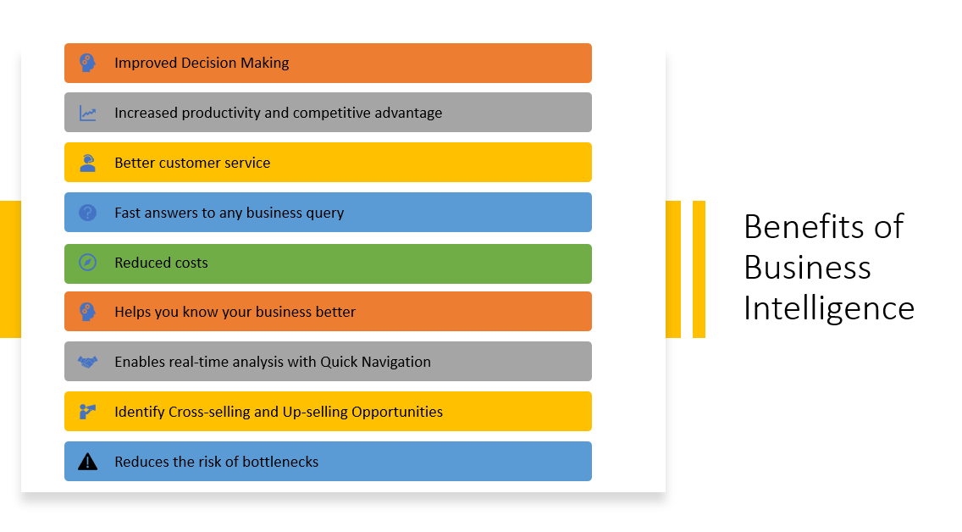

There are many benefits to using BI, including:

* **Improved decision-making:** BI can help businesses make better decisions by providing them with insights into their data. This can help businesses identify trends, optimize their operations, and allocate resources more effectively.
* **Increased productivity:** BI can help businesses improve their productivity by automating tasks, streamlining processes, and providing employees with the information they need to make decisions quickly and easily.
* **Better customer service:** BI can help businesses improve their customer service by providing them with insights into customer behavior. This can help businesses identify customer pain points, improve their products and services, and provide better customer support.
* **Reduced costs:** BI can help businesses reduce their costs by identifying areas where they can be more efficient. This can include reducing waste, improving inventory management, and negotiating better deals with suppliers.
* **Increased competitive advantage**: BI can help businesses gain a competitive advantage by providing them with insights into the market and their competitors. This can help businesses identify new opportunities, develop new products and services, and improve their marketing strategies.

Here are some additional benefits of BI:

* **Increased visibility:** BI can help businesses gain a better understanding of their operations and performance. This can help them identify areas where they can improve and make better decisions.
* **Better communication:**BI can help businesses communicate more effectively with employees, customers, and partners. This can help them build stronger relationships and achieve their goals.
* **Data-driven culture:** BI can help businesses create a data-driven culture. This means that decisions are based on data, rather than gut instinct. This can lead to better decision-making and improved performance.

**Key points to improve Business Performance:**

If you are considering implementing BI in your business, there are a few things you should keep in mind:

* **Start with your goals:** What do you hope to achieve by implementing BI? Once you know your goals, you can start to identify the data you need to collect and analyze.
* **Choose the right tools:** There are a variety of BI tools available on the market. Choose the tools that best meet your needs and budget.
* **Get buy-in from stakeholders**: BI is a team effort. Make sure you get buy-in from all stakeholders before you start implementing BI.
* **Start small:** Don't try to do too much at once. Start with a small project and build on your success.

BI can be a valuable tool for businesses of all sizes. By following these tips, you can maximize the benefits of BI and improve your business performance.

**More Examples which can benefit Businesses:**

Here are some specific examples of how BI can benefit businesses:

* A **retailer** can use BI to track sales data and identify trends. This information can be used to optimize inventory levels, target marketing campaigns, and develop new products.
* A **manufacturing company** can use BI to track production data and identify areas where efficiency can be improved. This information can be used to reduce costs, improve quality, and shorten lead times.
* A **financial services** company can use BI to track customer data and identify potential fraud. This information can be used to protect customers and reduce the risk of financial losses.

Overall, BI can be a valuable tool for businesses of all sizes. By collecting, analysing, and reporting data, BI can help businesses make better decisions, improve their productivity, provide better customer service, reduce costs, and gain a competitive advantage.

**Types of BI Tools**

There are many different types of BI tools available, each with its own strengths and weaknesses. Some of the most common types of BI tools include:

* **Dashboards:** Dashboards are visual representations of data that can be used to track performance and identify trends.
* **Reports:** Reports are more formal documents that provide detailed analysis of data.
* **Data mining:** Data mining is the process of extracting insights from large datasets.
* **Online analytical processing (OLAP):** OLAP is a technology that allows users to analyze data from different perspectives.
* **Ad hoc analytics:** Ad hoc analytics allows users to explore data and ask questions without having to know how to use specific BI tools.

**Conclusion**

Business intelligence is a powerful tool that can help businesses improve their performance in a variety of ways. By collecting, analysing, and presenting data, BI can help businesses make better decisions, improve their productivity, provide better customer service, reduce costs, and gain a competitive advantage.

**Data Visualization**

Data visualization is the graphical representation of data. It involves transforming data into charts, graphs, maps, and other visual representations. The goal of data visualization is to make data more understandable and easier to interpret.

Data visualization is important because it can help people see patterns and trends in data that would otherwise be difficult to identify. It can also help people communicate data more effectively to others.

**Need of Data Visualization:**

The need for data visualization is growing as businesses and organizations collect more and more data. Data visualization can help businesses make better decisions, improve their operations, and communicate more effectively with their stakeholders.

Here are some examples of how data visualization can be used:

* A **retailer** can use data visualization to track sales data and identify trends. This information can be used to optimize inventory levels, target marketing campaigns, and develop new products.
* A **manufacturing company** can use data visualization to track production data and identify areas where efficiency can be improved. This information can be used to reduce costs, improve quality, and shorten lead times.
* A **financial services** company can use data visualization to track customer data and identify potential fraud. This information can be used to protect customers and reduce the risk of financial losses.

Overall, data visualization is a powerful tool that can be used to make data more understandable, communicate data more effectively, and improve decision-making.

**Various tools used for data visualization.**

There are many different tools that can be used for data visualization. Some of the most popular tools include:

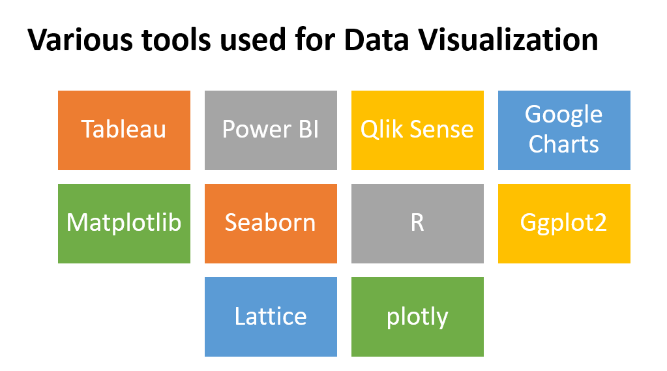**Tableau:** Tableau is a powerful data visualization tool that is used by businesses of all sizes. It is known for its easy-to-use interface and its ability to create interactive visualizations.



**Power BI:** Power BI is a data visualization tool from Microsoft. It is a popular choice for businesses that use Microsoft Office products. Power BI is known for its integration with other Microsoft products and its ability to create dashboards and reports.

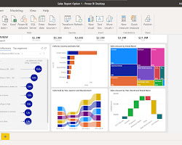

**Qlik Sense:** Qlik Sense is a data visualization tool that is known for its speed and scalability. It is a popular choice for businesses that need to analyze large amounts of data.

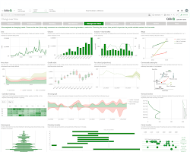

**Google Charts**: Google Charts is a free data visualization tool that is offered by Google. It is a popular choice for businesses that need to create simple visualizations.

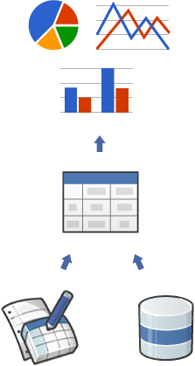

**Matplotlib:** Matplotlib is a Python library that is used for data visualization. It is a popular choice for data scientists and engineers.

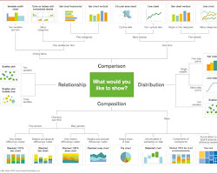

**Seaborn:** Seaborn is a Python library that is built on top of Matplotlib. It is a popular choice for data scientists and engineers who want to create beautiful visualizations.

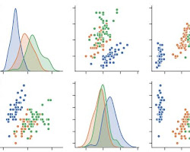

**R:** R is a programming language that is widely used for statistical computing and data analysis. It is also a popular choice for data visualization. R has a number of powerful libraries for data visualization, including ggplot2, lattice, and plotly.

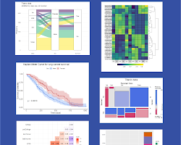

* **ggplot2:** ggplot2 is a popular R package for data visualization. It is known for its flexibility and its ability to create beautiful visualizations. ggplot2 is based on the grammar of graphics, which is a systematic approach to data visualization.

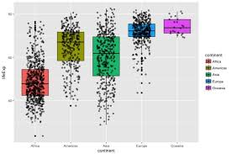

* **Lattice:** Lattice is another popular R package for data visualization. It is known for its ability to create complex visualizations. Lattice is based on the lattice graphics system, which is a powerful tool for creating statistical graphics.



* **Plotly:** Plotly is an R package that allows you to create interactive visualizations. Plotly is based on the Plotly.js JavaScript library, which is a popular tool for creating interactive visualizations.

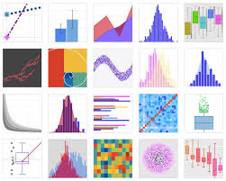

**Power BI**

Power BI is a business intelligence and data visualization tool that converts data from different sources into interactive dashboards and reports. It is a suite of software, connectors, and services that includes Power BI Desktop, a SaaS-based Power BI service, and mobile Power BI apps for different platforms. Business users can use these services to consume data and build BI reports.

Power BI is one of the most popular business intelligence and data visualization tools. It is a collection of apps, data connectors, and software services that can be used to collect data from different sources, transform it, and create informative reports. Power BI services are based on SaaS, and there are mobile Power BI apps available for different platforms. These services can be used by business users to consume data and build Power BI reports.

Here are some of the key features of Power BI:

* **Data connectivity:** Power BI can connect to a wide variety of data sources, including Excel spreadsheets, databases, and cloud-based services.
* **Data analysis:** Power BI offers a variety of tools for analysing data, including filters, measures, and calculations.
* **Data visualization:** Power BI offers a wide range of visualization tools, including charts, maps, and dashboards.
* **Sharing and collaboration:** Power BI makes it easy to share and collaborate on data insights.

**Conclusion:**

Both BI and data visualization are essential tools for data analytics. BI allows businesses to collect and analyse data from a variety of sources, and data visualization helps businesses to communicate the results of their analysis in a way that is easy to understand.

In today's data-driven world, BI and data visualization are more important than ever. Businesses that are able to collect, analyse, and visualize data effectively will be able to make better decisions and gain a competitive advantage.

Power BI is a powerful tool that can be used by businesses of all sizes. It is a good choice for businesses that want to collect, analyze, and visualize data to make better decisions.